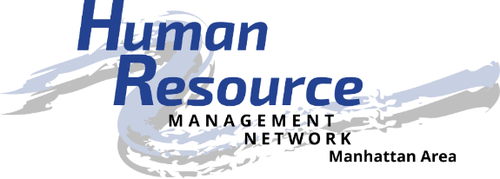
Be the catalyst to empower the advancement of human resources.

Job Description

Position: SHRM Foundation Liaison
Position Summary: Educate, promote and represent the interests of the SHRM Foundation and its activities to the chapter membership.
Responsible To:
- Members of the chapter
- Chapter president and board of directors
- State council SHRM Foundation director
Essential Duties and Responsibilities:
- Educate chapter membership regarding the purpose and ongoing activities of the SHRM Foundation including:
  - SHRM Foundation’s education resources
  - Status of the annual campaign
  - Upcoming deadlines and events
- Solicit donations to the SHRM Foundation through raffles and other activities at monthly meetings as a show of support for the human resources profession and SHRM Foundation activities.
- Advise chapter membership of the SHRM Foundation’s activities and fundraising needs.
- Participate in the development and implementation of short-term and long-term strategic planning for the chapter.
- Represent the chapter in the human resource community.
- Attend all monthly membership and board of director’s meetings.
Other Duties and Responsibilities:
- Provide contacts and resources to help grow and develop the organization and its members.
- As an active Board member, submit agenda items for board and chapter meetings, ask critical questions, and assist with Board decisions that affect Chapter membership.
- Must be in “good standing” within the Chapter.
- Know or build knowledge about the Chapter and SHRM.
- Follow SHRM Code of Ethics.
- Stay informed of human resource trends and timely issues affecting the profession and organization.
- Assist with social media applications.
- Maintain confidentiality of chapter board issues and membership data.
- Maintain adequate records for use by successors and other board members.
- SHRM membership is strongly encouraged.
Requirements:
- Present a professional appearance and friendly manner
- Be dependable and punctual
- Willingness to participate and engage in chapter and community activities as a volunteer
- Be courteous and personable when dealing with the public
- Be self-directed, willing to take initiative, and detail-oriented
- Respect and maintain confidentiality of HRMN volunteers, partners, and donors
- Computer skills are desired, but not necessary
Training & Resources:
- Attend Volunteer Leadership Academy
- HRMN By-laws
- HRMN website http://hrmn.shrm.org
- Volunteer Leadership Resource Center website http://community.shrm.org/vlrc/home
- SHRM website http://shrm.org
Time Commitment:
- Once per month for board meeting (approximately 1.5 hours, typically 8:00 – 9:30 am)
- Once per month for membership meeting (approximately 1.5 hours)
- As needed to prepare raffle items (approximately 1 hour per month)
Benefits:
- Volunteer opportunities
- Community involvement
- Apply, develop and improve leadership skills
- Build and improve your HR competencies
- Expand your professional network – locally, regionally and nationally
- Share your knowledge and learn from others
- Build relationships of trust
- Be a recognized catalyst for the HR profession
- Be recognized by external stakeholders for your HR expertise

Human Resource Management Network of Manhattan, KS, an affiliate of the Society for Human Resource Management, is located in the heart of the Flint Hills of eastern Kansas. Membership is composed of management and administrative level persons responsible for human resource related activities in the organizations. Our local chapter includes members from several local communities and surrounding counties. We are a local resource for networking, information, professional development, and continued support of excellence in Human Resources. For more information, visit www.hrmn.shrm.org.

